Experiment 6

DRIVING METHODS OF SYNCHRONOUS MOTORS AND OBTAINING ITS V-CURVES

# PURPOSE OF THE EXPERIMENT

Purpose of this experiment is learn how to drive a synchronous motors with different methods, study the asynchronous driving of a synchronous motor and observe the operation conditions. Also in this experiment one of the main purposes is to obtain the V curves of a synchronous motor.

# CONNECTION DIAGRAM

//çizildi

# EXPLANATION of Experıment

In this experiment, synchronous motor is drove using asynchronous driving technique. Asynchronous driving is done by connecting a relatively high (up to 9 times of excitation coil resistance) resistor to the excitation coil to avoid high starting currents to destroy windings. When the asynchronous speed approach to the synchronous speed dc current is given to the rotor windings. Used motor is a salient pole motor, because of this reason until passing on to the synchronous speed motor was in an unbalanced state, drawing a highly diverging current.

Measurements are made with no-load, half-load and full-load. All armature currents, active powers are noted to the experiment sheet. Power is measured using Aron connection method and two wattmeter (figure 1).

Aron connection method is convenient because uses two wattmeter. In case of one wattmeter one should consider there is an artificial zero point and therefore a balanced load. But in practical applications it is nearly impossible. There is always a slightly difference between phases [1].

In Aron Connection,

Total power = |W1 + W2|

COS PHİ = W1 -+ W2 / sqrt(3)*u*I

In experiment 50A:5A current transformer is used also wattmeter is used in x5 mode. So;

Active power = |W1+W2|*10*5

Then using

S2 = p2+ q2 and

Cosphi =

Sin phi =

Reactive power, cos and sin values are obtained.

It can be seen in the

//ölçümler

//bağlantı şeması

//yapılışı

//denklemler

//

Aron connection of wattmeters ( source: deneyler,

One wattmeter and artificial zero point measurements assumes the balanced load. But in practical it is nearly impossible. There is always a slightly difference between phases. (deneyler, pg: 18)

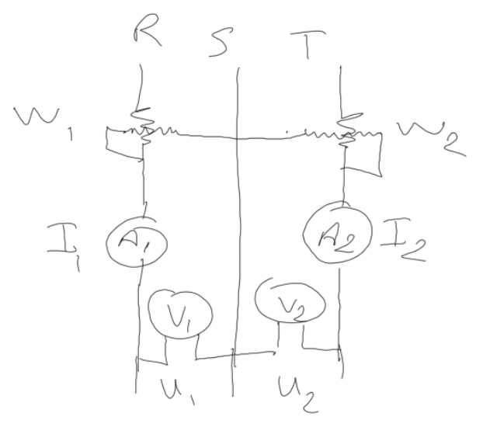

Total power = |W1 + W2|

COS PHİ = W1 -+ W2 / sqrt(3)*u*I

# QUESTIONS

1. Asynchronous driving is done by connecting a relatively high (up to 9 times of excitation coil resistance) resistor to the excitation coil to avoid high starting currents to destroy windings.
2. The starting moment of a synchronous motor while driving asynchronously can be increased by using a high resistance valued wiring materials such as bronze and brass.
3. We can see in graphic 1 that armature current can be adjusted by changing the excitation current. Also in figure 2 and 3 sinphi and cosphi changes relatively to the excitation current. Using this feature motor can be controlled to work in capacitive or inductive area by changing the excitation current.

# RESOURCES

[1] BODUROĞLU, T., Elektrik Makinaları Deneyleri, 1983, p.18-19

Levent Ovacık Lecture Notes